**COMPETITION**

I looked for apps that had functionality similar to our renewable energy game.  
I couldn’t find much by using the keyword energy, I saw lots energy consumption applications, however. By searching for “wind turbines” I found an app called Windmaster.  
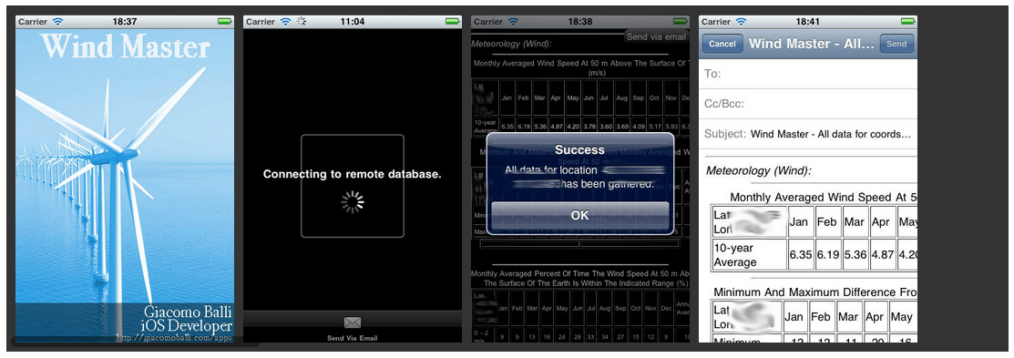

While the app doesn’t look very interactive, nor aimed at children, apparently it gives you data to see if it’s feasible to generate renewable energy via wind turbines. The information is specific to the city you’re in, so the results change depending on where you are in the world. This is somewhat similar to our idea, we could possibly gather information for our app from Windmaster.

After a little more google searching, I found Electrocity, a game built by Genisis Energy.. and the idea is almost exactly like ours, though the gameplay is different. 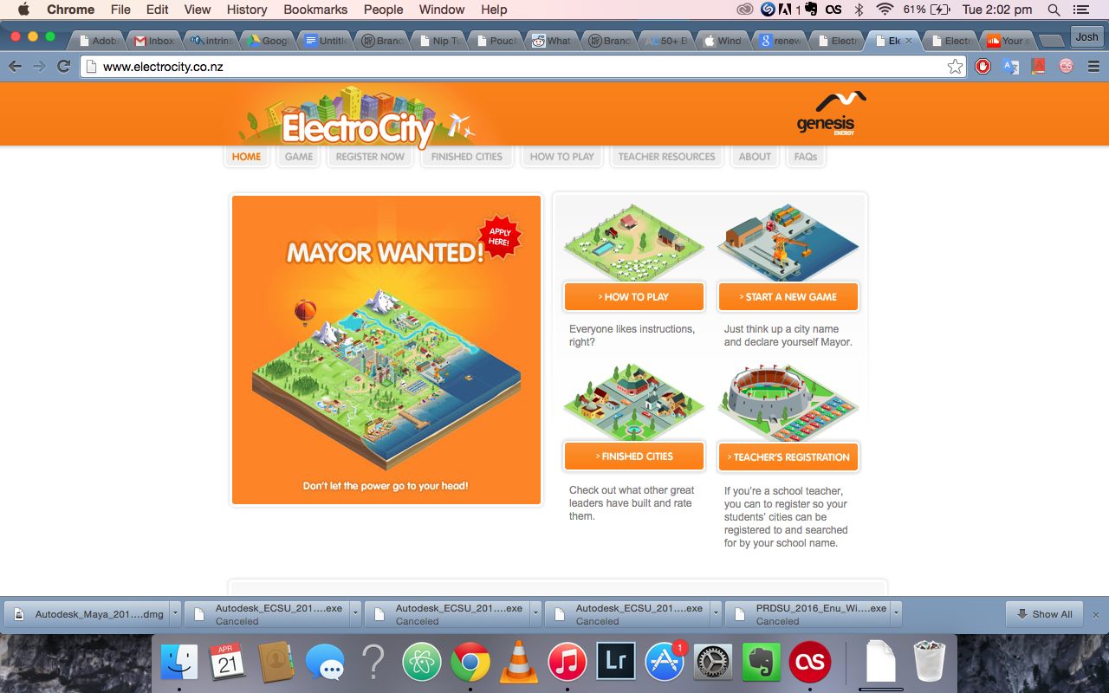

*“ElectroCity is an online game that has been developed specifically for teachers and students between Years 7 and 9. Students build and manage their own virtual towns and cities, making important decisions and learning about energy generation, environmental management and many more practical and relevant concepts. There is plenty of real-world information built into the game and kids can put that information to good use in their own cities.”*

I had a very brief look through it and the gameplay seems very slow and hard to pick up. It’s unclear where to click or how to interact with the game, so I think that we should definitely focus on how children are going to use our app and how we can make gameplay instinctive for a young demographic.

Other features of the Electrocity game:

* Electricity generation
* Environmental impact
* Supply and demand
* Tourism
* Energy efficiency
* Budgeting and Local Body Rates
* Buying and selling on a
* fluctuating market
* Coal and gas prospecting and extraction
* And much more…

http://www.electrocity.co.nz

**Apps on android**

**Author: Tianfu Yuan (Tony)**

There was quite lot of power app on android device. Here is some apps that I found on the market:

1. Bax3DPlayer

<https://play.google.com/store/apps/details?id=com.baxenergy.bax3dplayer>

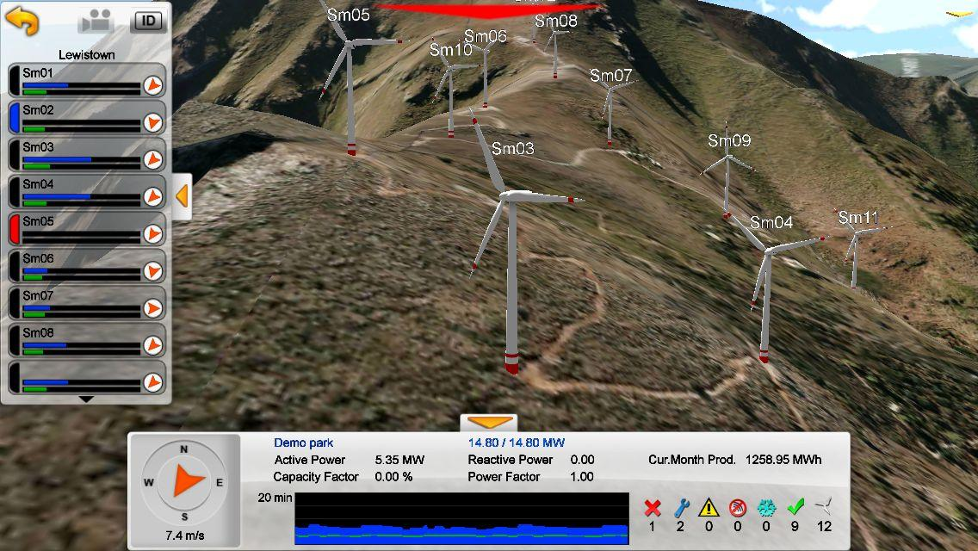

This app can check the real-time data from wind-turbines, which located at different wind farms.

2. Wind Power Station 3D

<https://play.google.com/store/apps/details?id=com.arcedepower.WindPowerStation3D>

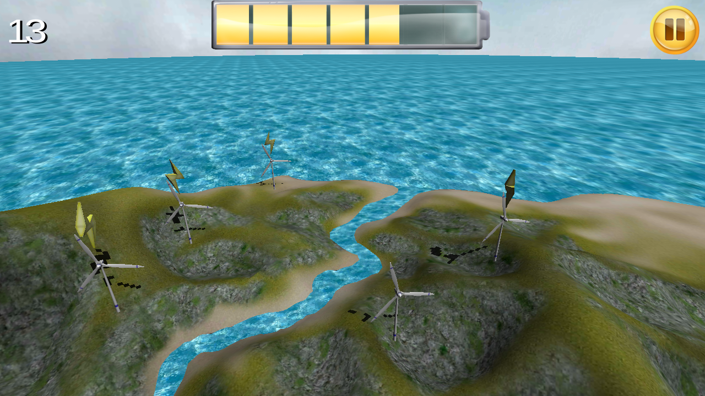

This app is like the “sand-box” app that you can place your own wind turbine anywhere that you want.

**Apps on iOS**

**Author: Tianfu Yuan (Tony)**

1. Wind Whackers

Wing Whackers by Wing Whackers, Ltd  
<https://appsto.re/us/_OUIF.i>

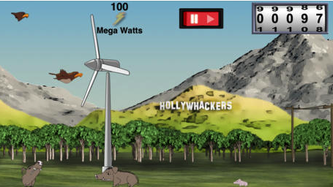

This app is similar to our designed app, but it only can do the wind turbine thing. By the way, it is the game but not for education purpose.

2. RoboTex: Turbine Spinner

<https://itunes.apple.com/us/app/robotex-turbine-spinner/id928682527?mt=8>

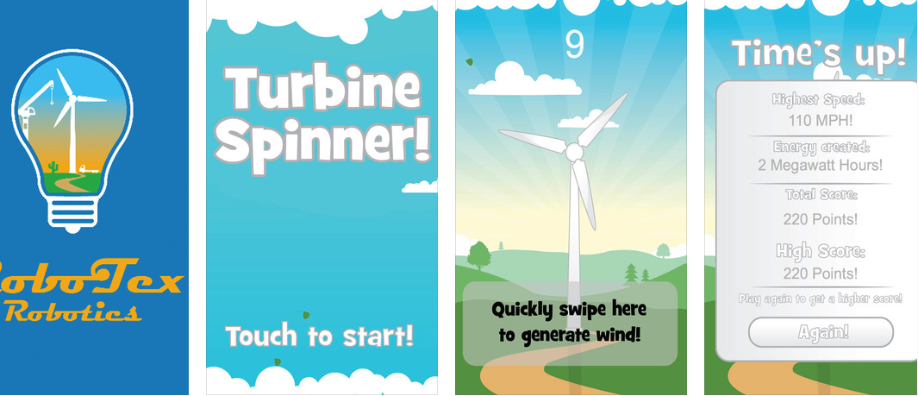

This app is game app, but it was really boring one.

**Apps on WP**

**Author: Tianfu Yuan (Tony)**

None.

Conclusion: Most of apps is for business or utilities purpose. None of them is about educational app for kids. So we are the only one educational game app on the market (android, iOS, WP).